Ctech Interviews 2021-22

Rohit

Microsoft:
- Explain your Project
- He told me to further explain it with an application.
- Then he gave me this problem and asked to read it and then he explained it to me.
- And told me to create a classes where I have to implement different functionality . He told me let's suppose there is a bank and there are many clients. And clients having different functionalities 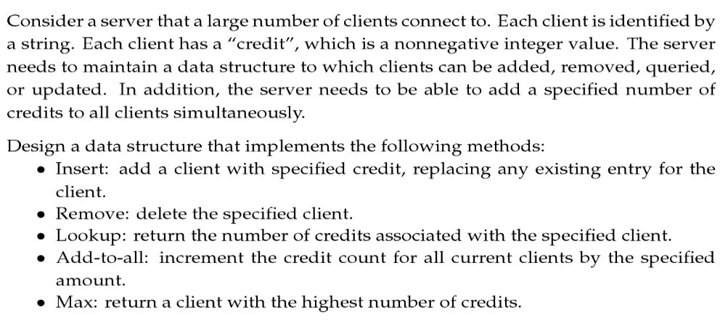
- At first I was feeling uncomfortable… But the interviewer was polite and helpful...so I thought I should give it a try. So I started with implementing functions.. in parallel, I'm giving reason for whatever I'm writing on the compiler.
- After implementing it roughly, I went through the code once and I pointed out my mistakes.
- He told me to modify the Max function that will print top 5 credits.
- He told me to tell him at what test cases my code is going to fail.
- At the end he told me that if you run your code it's not going to work (a lot of test cases will fail) but he said the approach looks fine.
- He pointed out my gpa and told me your gpa has never been so great. Then why do we hire you?

Verdict: [Selected]

Intel:
- Explain your project.
- Asked about my xv6 kernel project.
- What is XV6?
- How the system call works.
- How you added a system call in xv6.
- What is kernel?
- What context switching.
- And some stuff from projects.
- Check if the given binary tree is a mirror image of itself.
https://www.geeksforgeeks.org/symmetric-tree-tree-which-is-mirror-image-of-itself/

- Create a template for fun(3,3) and fun(3.5,3.5).
- What is polymorphism?
- Difference between overloading and overriding.
- What is run time polymorphism?

Verdict: [Unknown]

Texas Instruments:
- Introduce yourself.
- Didn’t ask much about projects.
- They are interested in coding skills so started with the coding part.
- Given two sorted arrays, merge them to a new sorted array.
https://www.geeksforgeeks.org/merge-two-sorted-arrays/

- What is recursion, explain with an example.
- If a number n is given, calculate the product of all odd and even numbers less than n.
- They asked me if I had any questions.

Verdict: [Selected]

Kakul

- Google
Note: Couldn’t disclose questions due to NDA

- There were 3 rounds
- They only asked DSA ques
- One question was asked in each round but after you implement the solution , a number of followup questions were asked related to implementation or optimisation or some other things were added into the question
- They encouraged to communicate whatever I was thinking
- Also gave some a hint once when I was going in the wrong direction

Verdict: [Selected]

- Microsoft

Ques: You are given a dictionary of words and a matrix in which each element is an alphabet. Print all the possible valid words that could be formed if you start traversing from any element in the first row and can move in all the 8 directions. One element can be traversed once.

Verdict: [Selected]

- Goldman Sachs

Round 1 :

- Given a linked list with the characters of your name as the nodes in the same order as they appear in your name. Create a new linked list in which each character appears in the lexicographically with all its occurrences occurring together.
E.g. kakul -> akklu

Round 2:

- Write the code to calculate the minimum length of supersequence of two strings.
Response: I used DP to first calculate the length of largest common subsequence then used it to get the final result
- Can it be done without calculating the length of the largest common subsequence?

Round 3:

- Why do you want to join Goldman Sachs?
- Asked about one of the project in which I used MySQL to create an e-market app
- What are primary and secondary keys in MySQL
- There are a large number of products in an organization. I want to filter the products on the basis of features like color, shape, size. Which data structure will you use to store the products so that products can be filtered easily on the basis of selected features.
- A great deal of discussion and followup questions on the approach I proposed
- Which data structure will you use to store the vacant seats in an airplane so that you could allocate contiguous seats to customers while reserving seats.
    - Again a great deal of discussion and followup questions on the approach I proposed

Verdict: [Selected]

- Nvidia

- Introduce yourself
- A long discussion on my Thesis (around 25-30 min)
- Array Implementation of Queue
- Questions related to my OS assignment of paging framework like what you implemented and how
- Asked about Interrupts (I mentioned about them while telling about page fault in above ques)
- Asked about my interest and why I joined this branch and what I learnt and why would I like to join Nvidia
- Asked to write an API to align memory but I couldn’t understand so he didn’t ask further due to lack of time

Verdict: [Unknown]

- Qualcomm

Round 1:

- Write the code to tell if the given binary tree is a binary search tree or not
- Difference between C and Java and which are interpreted based languages among C++, Python and Java
- What are the advantages of using Templates
- What are virtual functions

Round 2:

- Merge overlapping subintervals problem
- Given an unsorted array of N numbers. Each number lies between 0 to N-1. Print all the repeating numbers.
Response: I told brute force approach in O(NlogN)

Ques: Can it be optimised?
Response: I told the solution in O(N) time and O(N) space

Ques: Can it be done in O(N) time and O(1) space?

- Given an unsorted array of N numbers. There is no limit on the range of numbers. Find the first positive number which is missing in O(N) time and O(1) space

Verdict: [Unknown]

Anurag
- Qualcomm (ML systems engineer)
Round 1 : (1 hr)
- First 30 mins grilled on ML/DL. Overfitting/Underfitting, how to know if there is overfitting/underfitting, Importance of PreProcessing, different types of preProcessing techniques in Computer Vision, meaning of validation score, YOLO algo, NMS suppression basics(did this in a project), advantage of ResNet over the older DL architectures ( hint: skip connections), Dimensionality reduction(PCA).

- Next 30 mins, asked two DSA questions.
1. Merge two linked lists
2. Divide an array into two subarrays s.t. The difference between the subarrays is minimum. Return the min difference.

Verdict: Unknown

2. Intel (SWE)
Round 1: 30 mins
- Asked about project
- Given a LL say 1 - 2 - 3 - 4 - 5.
Rearrange it to 1 - 5 - 2 - 4 - 3

Verdict : Unknown

- MaxLinear (Sr. SWE)
Round 1 : 1hr 15 mins
- OS topics : sys calls, mode switch, advantage of multithreading over multiprocessing, real life examples of multithreading and multiprocessing, PCB, locks, semaphores, branch prediction, IPC
- bit manipulation problems, simple coding question like check palindrome, different approach like starting from the extremities or starting from the centre while checking for palindrome
Round 2 : 1 hr
1. What should be the optimal characteristics of an embedded system ?
Ans : Responsive and optimal space
2. Why do we use C in an embedded system and not C++ ?
Ans : C++ has a large library. So, during linking the entire library of c++ will be copied because of which the executable size will become large.

- Puzzle question : Monty Hall problem (can be found on top 50 puzzles of GFG)
- The last question was very interesting. They told me that in an embedded system, we generally don’t use malloc function because malloc is usually used for complex OS and the space management i.e. fragmentation is not that optimally taken care by the malloc function. So, in most cases, we write our own malloc function. They asked me to give solutions.
Ans : The problem boils down to hole management in the memory. So, started to make up wild ideas like maintaining an array of pointers or create a DLL where each node consists of the starting address, ending address, filled/empty bit. Whenever a hole will be created, we can simply merge this hole with neighboring holes thereby creating larger holes. Note that in embedded systems, we usually don’t come across the concepts of virtual memory and so, the memory management in embedded systems is more or less contiguous.

Round 3 : HR round (15 mins)

Verdict : Selected

Paresh
Nvidia
Two interviewers, first asked about my interests etc.
- Write a program to count set bits without using recursion or loops.
I was unable to do it . He mentioned that if I have not heard about the approach already, I will not be able to do it. He told me the approach . Don’t remember it now but you can google it.
Told me to use recursion or loops and code, I did.
- Tell the output of a program based on pointers. I made a blunder here and gave the wrong answer and realized it soon. But they had moved on to the next question. They didn’t mention whether the answer was right or wrong. Don’t panic, take your time and think carefully before answering.
- Asked me about polymorphism and to explain it.
- Explain runtime polymorphism using code (two classes)
- What is constructor and destructor?
- Which destructor is called first and why(base or derived)?
- Can constructor and destructor be made virtual?
- Project - socket programming
- Coding question I don't remember the exact question but was something like given a string(s) and a dictionary of words print combination with each letter of string with words in the dictionary.
Ex. String – TOM, dictionary- [ CAT, TOY]
Answers – TCAT, TTOY, OCAT, OTOY etc.
Was unable to give any optimized approach just brute force.
- Why shift to Ctech from electrical, last job etc.
- Any questions?
I did not prepare specific questions for each company so at last I just asked the same general questions to interviewers like work culture, training program, job profile etc. in all the interviews.
Verdict-Not selected

Microsoft
Only one interviewer. Asked to explain any one project I explained branch predictors. Asked just basic questions about the project and in the meantime was searching for a problem.
Two coding questions
- Find the largest subarray or contiguous subsequence with sum 0.
I told him the approach using hashing and also answered some of his questions regarding my approach. Seemed satisfied and didn’t tell me to code it.

- You are given a dictionary of words and then an array of strings. You have to find all the words from the dictionary which are just one letter different from strings in the given array.
Ex. Given array [ TOM, CAT, DOLL] and consider a dictionary with many words
Answers will be POM, TAM, PAT, TOLL, DOLS and so on.
Told him first the brute force approach and he told to optimize it
Told him to approach using trie, he asked about time complexity etc and told to optimize it further.
He told me that we can also do it by making a graph of dictionary words where each node will have a string and two nodes will have an edge between them if they have only one letter different.
Asked me if given this graph whether we should use bfs or dfs.I answered bfs first ,thought a little and told it will be dfs.
As only around 10 minutes were left, he then just told me to write a function quickly assuming the graph is already created from the dictionary etc. and explain it.I wrote it and also corrected the mistakes. At last, he said fine and told me if I had any questions. I knew my code was not 100% correct and may fail for some test cases.
Verdict-Not selected

Texas
As soon as the interview started, I got notifications from hirepro for an intel interview. I didn’t know it was a browser notification and asked for some time . They were very patient and asked me to take my time and fix it.
Two interviewers, one was from iit Delhi. He was the one who asked all the questions in the interview.
First, they introduced themselves and told me about their work etc. I did the same
- Asked me what is big endian and little endian. I said I have heard about them but don’t remember much. He explained to me and asked this question
https://stackoverflow.com/questions/4181951/how-to-check-whether-a-system-is-big-endian-or-little-endian
Told me to code it.
It was a tricky one but the interviewer helped me a lot in this question by giving hints.
- Find and remove loop in linked list question
Just asked me about the approach. I gave two approaches using hashing and a slow & fast pointer.
- There were two questions based on system design.
Showed me a pic. There were multiple cores, one was connected to the sensor, one to LED, one to flash etc. Asked my approach to handle different problem cases and their solutions. It looked difficult at first but all questions were based on cache, write back, write through, DMA, mutex locks, hardware locks etc. I just had to tell where and how to use them.
There was one more question which I forgot. But similar to the above one for different scenario.
I was confident of being selected at least for the HR round. Got a phone call from HR that I am selected and he asked general questions like family, whether I will join the company etc.
Verdict - selected

Qualcomm
It was only for ML profiles and I hadn’t studied ML for interviews except for projects.
- 25 horses puzzle.
Puzzles are rarely asked, just go through puzzles from geeks for geeks and you can answer them easily.
- Find the element in the array with left and right sum equal. Told me to code it.
- He asked me whether I did any project on ml as I had not mentioned any ml project in my cv.
I mentioned my M-tech project where we have used neural networks.Was able to answer basic questions about NN but then he started asking questions in depth.
- Project in cv about image processing. Asked about it and algorithms. I told we used k-means, region growing, thresholding etc.Asked me to explain k-means which I did.
- Socket programming project.
- One more coding question which I don’t remember but it was among the must do questions in geeks for geeks. Told me to just tell the logic and not to code.
He told me that they were looking for candidates with a good ML background for their team. I answered all questions except tough ml ones but knew I wouldn't be selected here.
Verdict-Not selected

Meenakshi
Google
- Implement the Jaccard index formula.
Verdict-Not selected
Qualcomm
- What is clustering?
- Code to find distance between two nodes.
- Triplets with sum zero.
- Find the minimum in k size of the subarray.
Verdict-Not selected
Microsoft
- Find the element in a 2d sorted array (row and column wise sorted).
- Write integers into words (e.g. 102 -> one hundred two).
Verdict-Not selected
Goldman Sach
- sort the array having 0,1,2.
- Find the minimum element in rotated array
- Puzzle -> you have three buckets, one contains orange , another contains apple and third one contains both orange and apple but they are labeled wrong in how many iterations you can find the right one.
Verdict-Not selected
Oracle
- Tell me about yourself.
- Asked about project
- Find the substring which contains all the distinct characters
Verdict-Not selected
Max linear
1st round:-
- Tell me about yourself.
- Explain the project and questions on the project.
- What are interrupts and how do the CPU handle interrupts?
2nd round:-
- Write code to Implement queue using stack. Memory structure allocated to the program.
- What is mutex and semaphore, real life examples where we use them.
3rd round:-
- Tell me about yourself.
- Which type of work you want.
- From where you are.
Verdict - selected
Samsung
- Find the median in the linked list.
- What is virtual memory? How much virtual memory can be used in a computer?
- puzzle: - In the below image two persons are standing on A one go from a-o-b and another go from arc. Then what should be the angle A nOB such that both people meet at B at the same time . both have the same speed. Ans: 2 radion.
- 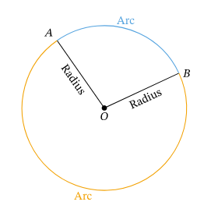
Verdict-Not selected.
Akash
Intel
- Different scheduling policy in brief their advantages and disadvantages
- Difference between semaphore and mutex, what is spinlock
- socket programming, steps on client side & receiver side
- one coding ques, Given n oranges, need to divide in m basket such that the difference between no. of oranges in two consecutive basket is 1. Ex- n=10, m=5 o/p= 1,2,3,4
- Difference between interrupt and exception
- what is virtual memory, paging, Design LRU Cache
- DMA controller, Cache coherence problem
Verdict: Unknown
Qualcomm
- Code Longest increasing subsequence
- Given n numbers from 1 to n , need to find repetitive elements in O(n) time O(1) space
- Quick sort, time complexity, worst case
- what is polymorphism, overloading & overriding
Verdict: Unknown
Goldman Sach
- find real roots of x^5+4x+1=0
- One coding ques which needs to be done in O(n) time and O(1) space
- Given 201 tosses, find probability of no. of heads is greater than no. of tails
Verdict- Not selected
Max linear
1st round:-
- Tell me about your thesis work, what challenges you have faced
- Scheduling policy , their performance parameters
- Semaphore, mutex, socket programming, what are pipes, difference between sockets and pipes, layers of OSI model
- Code to check whether a no. is divisible by 3
2nd round:-
- Dynamic memory allocation, what is memory leak, How to detect & handle memory leak, garbage collection mechanism, smart pointer
- Different storage class , their scope, storage location
- Code, Insert a node in Linked list after given node
- Puzzle – Measure 4l using jug of 3l and 5l
3rd round:- HR Round
Verdict- selected

Barclays
- Ques on thesis, what new you have implemented, challenges faced
- Difference bagging and boosting
- Random forest and decision trees
- Bias & variance , How to reduce overfitting in CNN
- mutable and immutable objects in python
- Then 4-5 behavioral ques
Verdict- Selected

